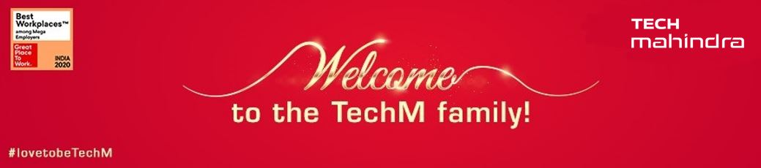

*Dear Associate*,

Welcome Onboard!

We are delighted to have you as a part of the Tech Mahindra Family!

We understand how difficult it can be to adjust to a new working environment. We are here to help you in any way we can and hence we would request you to go through all the information and the attached documents to understand the necessary requirements for your journey with us.

**Important links and portals:**

* OUR CULTURE Video: [A Tribute To The Tech Mahindra Culture - YouTube](https://www.youtube.com/watch?v=FWXZxUdqRsk)
* Citizens of the Future Video: [Message from Citizens of the Future | #TogetherWeRise | Mahindra Group - YouTube](https://www.youtube.com/watch?v=8tSZgBpkT28)
* Our Core Values: [Living the core values - Mr. Anand Mahindra - YouTube](https://www.youtube.com/watch?v=jYTPNUQXsag)
* TWINGO - [TWINGO (techmahindra.com)](https://twingo.techmahindra.com/Twingohome.aspx)
* My BeatPlus - <https://mybeatplus.techmahindra.com/>
* PACEHR - <https://pacehr.techmahindra.com/>
* Human Resources - <https://hr.techmahindra.com/>
* HelpNxt – Ticketing Portal - <https://helpnxt.techmahindra.com>

**Important Point Of Contacts**:

**MediAssist (Medical Insurance):**

* For any queries regarding medical insurance, connect with the mapped MediAssist SPOC for details. You can also visit the India Medical Insurance and Wellness portal from the below path:

TWINGO 🡪 HUMAN RESOURCE 🡪 INDIA MEDICAL INSURANCE AND WELLNESS 🡪 Contact 🡪 Insurance Contact.

* **PF Help desk** from the below path:

TWINGO 🡪 HUMAN RESOURCE 🡪 PF HELP DESK

**Technical Assistance:**

* For technical assistance please write to TIM Service Desk in the below mail ID: [TIMServiceDesk@TechMahindra.com](mailto:TIMServiceDesk@TechMahindra.com).
* For assistance regarding password reset or any related challenges, Call us at: 020-67261818 or 7799 - From Tech Mahindra Office Phones or Visit HelpNxt Portal: <https://helpnxt.techmahindra.com>.
* Connect to TechM approved Remote IT Assistance https://tim.techmahindra.com/itsupport provided by TIM Operations & 24X7 CSD.

**For Project related queries or any other assistance** – connect with your Business HR (BHR) or Reporting Manager (RM)

* **Meal Voucher -** Zaggle / Sodexo: Connect with Mapped BHR.

**Acronyms and Definitions:**

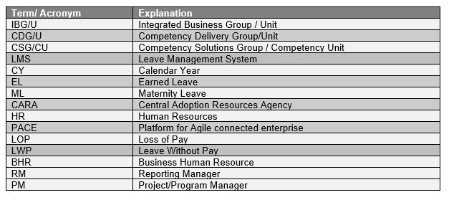

**Download Tech M Mobile App – mEasy**:

You may download the mEasy app for digital ID card as per instructions below:

* For android phones, go to Play Store and download the Apps - mEASY, myHub, and NeMo.
* To install mEASY iPhone app, visit the link <https://apps.techmahindra.com/> on iPhone Safari browser.
* Should you have any challenge, please write to [CIO.Mobility@techmahindra.com](mailto:CIO.Mobility@techmahindra.com)

**IOS Users:**

Also, a few things need to be taken care of while accessing the website.

* Make sure that the https:// should be deliberately prefixed with app.techmahindra.com.
* <https://apps.techmahindra.com> should be accessed from Safari browser in case of iPhone.
* Please login only using your Lan ID and Password.
* In case of iPhone, after the app is downloaded, please accept the certificate by navigating to Settings App > General > Device Management > Tech Mahindra Limited > Trust.
* After performing the following steps you’ll be able to access the M-Easy application.

**New Joinee Physical ID Card & DIGITAL ID Card:**

Kindly raise a request on CS tool under New Joinee IDCARD category. Please find the below path.

* TWINGO 🡪 CS Portal 🡪 Employee 🡪 ID Cards 🡪 Category 🡪 New Joinee IDCARD request

Kindly raise a request on CS tool under DIGITAL ID CARD category. Please find the below path.

* TWINGO 🡪 CS Portal 🡪 Employee 🡪 ID Cards 🡪 Category 🡪 Digital ID Card request

[https://csportal.techmahindra.com/](https://csportal.techmahindra.com/IDCards/Presentation/Associate/AssociateApplication.aspx)

**Other important information:**

**Personal Details:**

* You might have already updated all your important personal information such as Aadhaar, PAN, Passport etc. during the onboarding process. Still, we require you to check if all that data is updated correctly.
* Please follow the below path to review and update your personal information:

Main Menu 🡪 Employee Self Service 🡪 Personal Information

**Tax Declaration:**

* Tax declaration cutoff date for new hires – Window will be open for 30 days from DOJ.

**Payroll Cycle:**

* Payroll cycle – 21st of previous month to 20th of current month.
* Update bank details before the 20th of the month for salary credit.

**Salary Account:**

* Tech Mahindra has a tie up with 11 banks for salary accounts. Go to the below link to view the Bank SPOC information for your respective location.

Induction Portal - <https://kee.techmahindra.com/sites/HR/Induction/SitePages/Home.aspx>

* If you have an existing account with any of the partnered banks and wish to continue, you can update the same or you can create an account with our partnered banks and update the details in PACEHR portal in the below path.

Main Menu 🡪 Employee Self Service 🡪 Payroll and Compensation 🡪 India Pay 🡪 Transaction 🡪 India Bank Details.

**Mandatory Assessments:**

* Mandatory assessments have to be completed within 30 days of your date of joining.
* Access the assessments via iLearn mails ([ilearn_donotreply@sumtotalsystems.com](mailto:ilearn_donotreply@sumtotalsystems.com)) triggered to your inbox. The iLearn mail also has the due date for completion of the assessments.
* You can view all the learning assignments through the below path:

TWINGO 🡪 MAIN MENU 🡪 Training 🡪 Dext – Get Ahead 🡪 Login As Employee 🡪 My Mandates

**Teams and Outlook Access For Mobile Device:**

Go to <https://helpnxt.techmahindra.com>for raising access for MS Teams and Outlook on your mobile device.

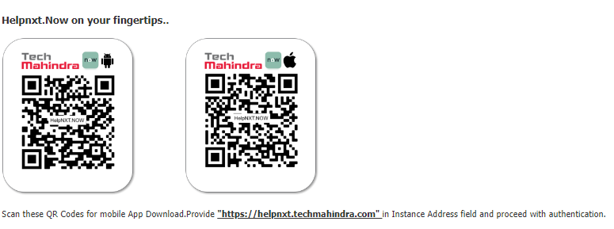

**MS Teams access for mobile:**

Follow the below path to raise request for MS Teams access for mobile.

* HelpNxt Home 🡪 Service Catalog 🡪 ISG 🡪 Service Desk (CESP) 🡪 MS Teams

  
  
**MS Outlook access for mobile:**

Follow the below path to raise request for MS Outlook access for mobile.

* HelpNxt Home 🡪 Service Catalog 🡪 ISG 🡪 Service Desk (CESP) 🡪 Mailbox (Outlook/Webmail) 🡪 SVC 034-MAM Enrollment Request.



______________________________________________________________________________

**Working hours and Timesheet:**

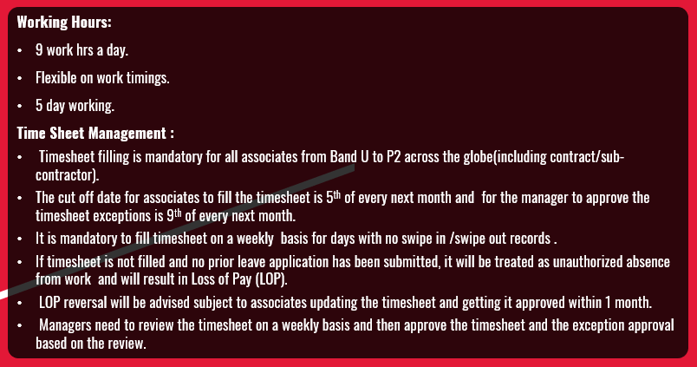

**Leave Structure:**

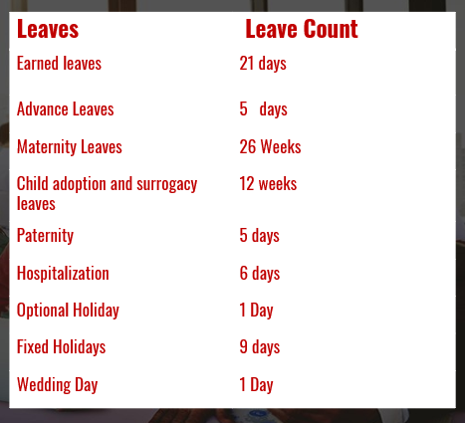

**Insurance Plan:**

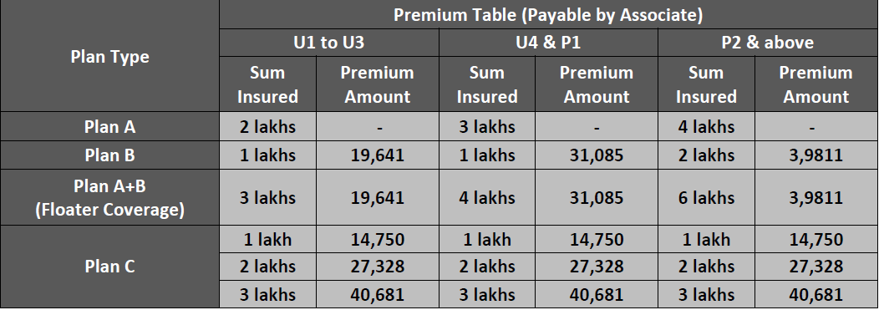

**AWT:**

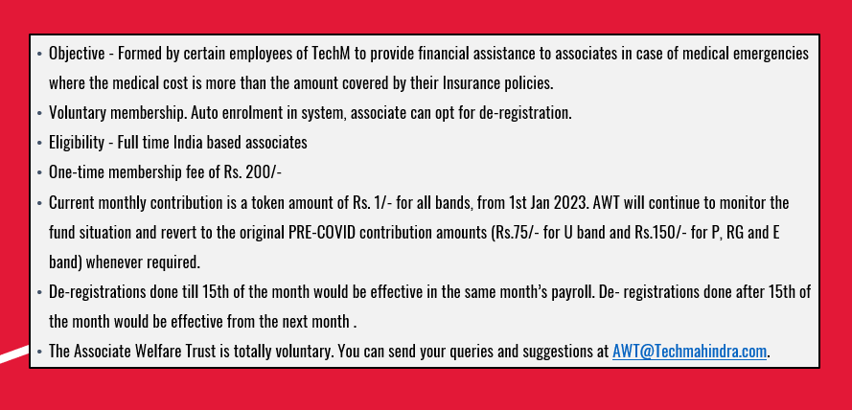

Disclaimer

Tech Mahindra Limited, herein referred to as TechM, provide a wide array of presentations and reports, with the contributions of various professionals. These presentations and reports are for information purposes and private circulation only and do not constitute an offer to buy or sell any services mentioned therein. They do not purport to be a complete description of the market conditions or developments referred to in the material. While utmost care has been taken in preparing the above, we claim no responsibility for their accuracy. We shall not be liable for any direct or indirect losses arising from the use thereof and the viewers are requested to use the information contained herein at their own risk. These presentations and reports should not be reproduced, re-circulated, published in any media, website or otherwise, in any form or manner, in part or as a whole, without the express consent in writing of TechM or its subsidiaries. Any unauthorized use, disclosure or public dissemination of information contained herein is prohibited. Individual situations and local practices and standards may vary, so viewers and others utilizing information contained within a presentation are free to adopt differing standards and approaches as they see fit. You may not repackage or sell the presentation. Products and names mentioned in materials or presentations are the property of their respective owners and the mention of them does not constitute an endorsement by TechM. Information contained in a presentation hosted or promoted by TechM is provided “as is” without warranty of any kind, either expressed or implied, including any warranty of merchantability or fitness for a particular purpose. TechM assumes no liability or responsibility for the contents of a presentation or the opinions expressed by the presenters. All expressions of opinion are subject to change without notice.

Thank You

Visit us at techmahindra.com